**LATEST NEWS**

**1. Real education in the Artificial World: Artificial Intelligence**

With Artificial Intelligence paving its way in, you not only change the way you learn, but also enables overcome the real world challenges, physical limitations, an adaptive learning to different learner styles and habits. The future lies in hand, with these sophisticated tools and technology. The complex equations broken down to output/ impact based learning. The area, which is being researched more with every minute to code the way, we learn, there by making learning for the millennials not only simple but, demonstrative and predictive.

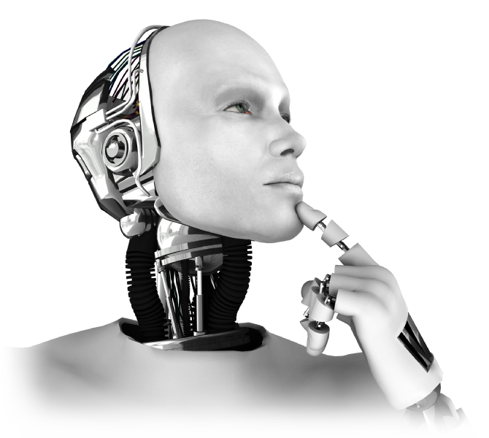Artificial Intelligence is a computer-based system, which includes speech recognition, language identification, visual perception, and decision-making etc. and can perform tasks that require human assistance.

For example, ***Siri*** is the personal assistant which comes along with iPhone. Another example is Google Voice Search “**Ok** **Google**”. These applications use voice or visual recognition and decision making. We can see social media websites, such as Facebook, that uses facial recognition feature to tag someone in photo.

Some of the big players where AI developers are in great demand are: Google, Facebook, Amazon, IBM Watson and many more.

A few top institutions which offer Masters in AI are University of Amsterdam, University of Edinburg, University of Georgia, University of Groningen, University of Southampton, IIT Bombay, IISc Bangalore and many more.

Artificial Intelligence is one such field which is attracting potential employers in recent years and it going to be an area which will see immense development.

**2. NIRF Ranking 2017: Indian Universities Ranking System**

Ministry of Human Resources and Development (MHRD) launched National Institutional Ranking Framework (NIRF). NIRF was introduced in 2016 to rank Indian Universities on various parameters such as:

1. **Teaching, Learning and Resources (TLR)** - Multiple factors such as student strength, faculty-student ratio, financial resources and their utilization etc. are used to assess institutes.
2. **Research and Professional Practice (RPP)** - Factors such as research papers and journals published, quality of publication etc. are used to rank institutes.
3. **Graduation Outcome (GO)** - Placements, median salary, ratio of students admitted to top universities etc. are the factors used to rank institutes.
4. **Outreach and Inclusivity (OI)** - Institutes are assessed on the diversity factor such as number of students from other states, women students etc.
5. **Perception** - Institutes are also assessed for peer and public perception.

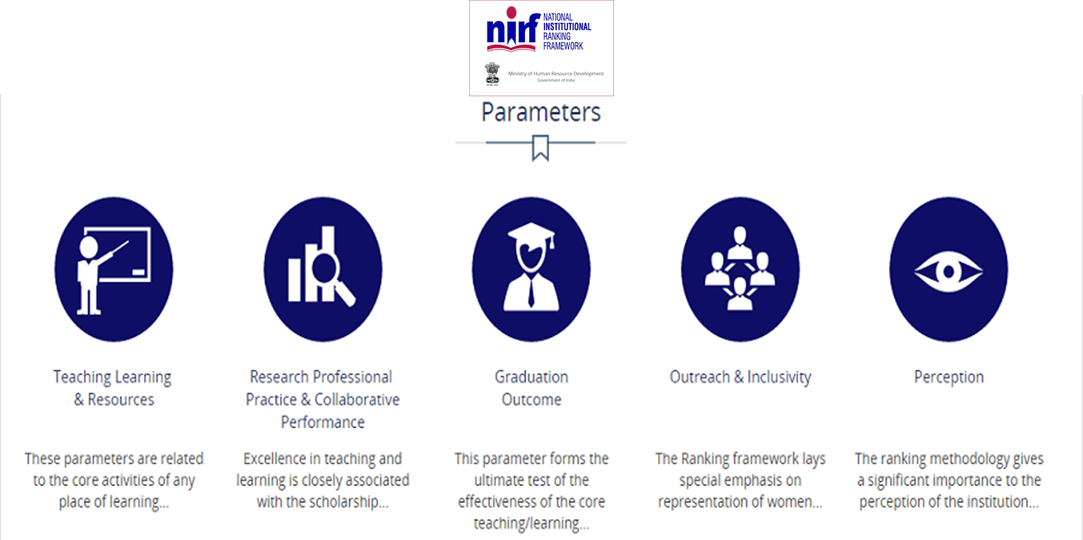

The maximum point for each criteria is 100. Therefore, weightage given to TLR is 0.30, RPP is 0.30, GO is 0.20, OI is 0.10 and Perception is 0.10.

IISc Bangalore has been ranked as the top university in India.

**3. MOOCs paving the way of learning!**

Online learning is a way of studying for an internationally recognized qualification without attending classes in physical campus. “MOOC” has been in trend recently, with lots of discussion about organizations like Udacity, Coursera and edX. MOOC is a free Web-based distance learning program designed for a large numbers of geographically dispersed students. Learning is ubiquitous, i.e., anywhere, anytime. More than 2 million people have signed up to Edinburgh courses across a broad range of subject areas. It is aimed at those who wish to study for a postgraduate qualification alongside work or other commitments.

Depending on the course, students may need to listen to or read lectures every day or just once or twice a week. Students are required to complete assignments online.

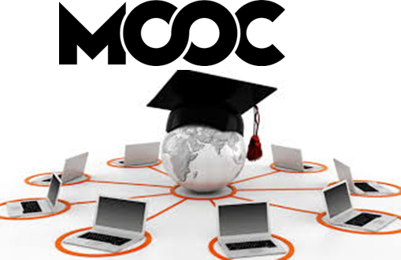

With online education, you have the power to pursue your dream program or course easily accessible from the comfort of your home.

Some high schools and colleges give you credit for many online courses (the ones offered by them). This can help students in getting ahead in high school/colleges by taking required courses online at their own pace.

An online degree from a prestigious university will boost your career and will make you a better candidate for a job promotion.

Many online courses are offered free of charge but don’t usually come with certificate of completion. MIT, for example, offers all course materials online without any charges.

MOOCs make you the master of your own education!

**4. Indian Higher Education: Vision 2030.**

According to E&Y Report Higher Education in India: Vision 2030, India will be among the youngest nation with nearly 150 million people in college going age group. All states need to adopt a transformative and innovative approach across all levels of higher education: from curricula and pedagogy to the use of technology to partnerships, governance and funding, to become globally relevant and competitive.

The states are benchmarked on various parameters and placed into four groups based on their performance across access and equity in education, and relevance and quality, governance and funding, and excellence.

1. **Sustain Leadership** group has above-average performance on both dimensions.
2. **Deepen Impact** has high performance on quality, low on access and equity.
3. **Invest in Quality** scores well on access and equity, but is low on quality.
4. **Restructure** has below-average performance on both metrics

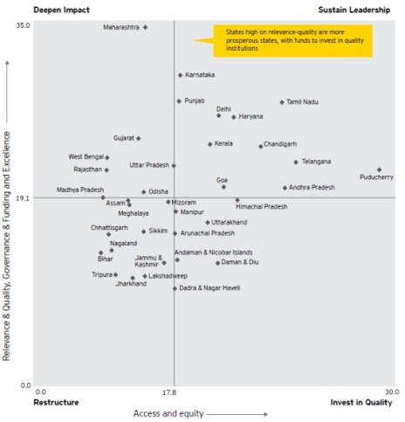

The report outlines a three-step recommendation roadmap for their HE development based on where the states are placed in the four quadrants:

1. **Core action points common for all four groups**

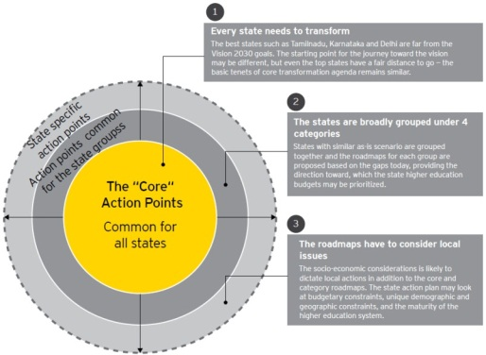

1. **Interventions specific for the four groups, including long-term recommendations and a 300-day action plan**

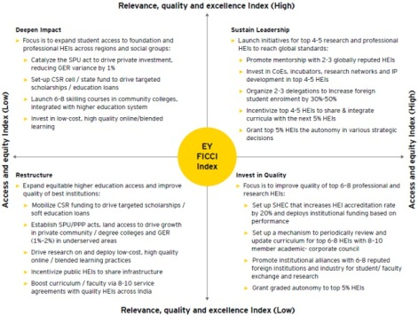

1. **State-level recommendations:** The state action plan may focus on budgetary constraints, unique demographic and geographic constraints, and the maturity level of the higher education system.

[Source: EY](http://www.ey.com/in/en/industries/india-sectors/education/ey-indias-vision-2030-a-state-focused-roadmap)

**5. MIXED REALITY: THE CURRENT BUZZWORD IN REALITY TECHNOLOGY**

Digital world is evolving very fast. ***Microsoft HoloLens*** is the coolest new advancement in technology. Microsoft HoloLens is an example of Mixed Reality concept. Mixed Reality (MR) is the hybrid of Virtual Reality (VR) and Augmented Reality (AR).

*What is Virtual Reality?*

Virtual Reality places the user into the virtual environment. The user wears a "head-mounted display" on his/her head which looks like a boxy set of goggles that holds a screen in front of his/her eyes, which in turn is powered by a computer, gaming console or mobile phone, often accompanied by 3-D audio or controllers that let you reach out and interact with this artificial world.

*What is Augmented Reality?*

Augmented Reality places the digital content (2D or 3D layered content) on top of the real world objects. It is often delivered through a sensor-packed wearable device.

*What is Mixed Reality?*

Mixed Reality works by scanning your physical environment and creating a 3D map of your surroundings so the device will know exactly where and how to place digital content into that space – realistically – while allowing you to interact with it using gestures. The use of transparent lenses, spatial sound and an understanding of your physical environment will allow holograms to look, sound and behave like real objects that are able to interact with the environment around them and also with each other.

**Watch**: [Windows Mixed Reality: An Evolution for Education](https://www.youtube.com/channel/UCT2rZIAL-zNqeK1OmLLUa6g)

‘Learning by Doing’ is impacting the education in a big way. VR, AR and MR technologies are changing the way students learn various subjects such as Science, Technology, Engineering, Arts, and Mathematics. Students can better understand the concepts by actually visualizing things. Thanks to our rapidly advancing technology!

Learning Solar System by children is a fun way now.

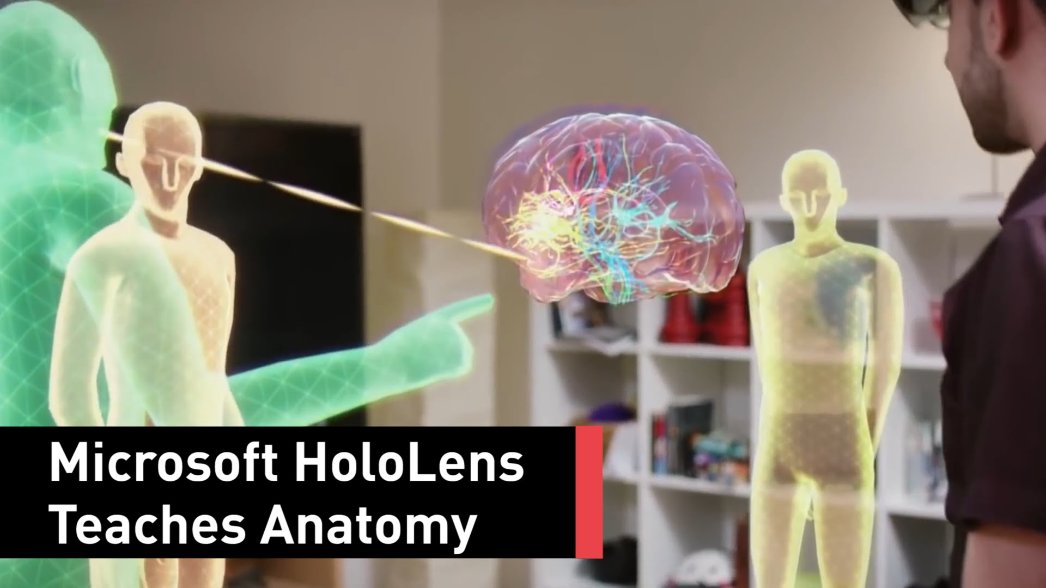The virtual lab is revolutionizing science classes. For our next generation doctors, learning [human anatomy](https://youtu.be/zmdRe_6lqtI) is made simpler.

Architects have to deal with shapes, space and light. Visualizing 3D model using MR technology gives much higher confidence and helps in better and effective decision making. [Visualizing design data in real world environment](https://youtu.be/kHSgL6vaOTY) helps in making sure that the design is implemented with highest accuracy on site.

In a few years, we will see MR technology transforming the world of education in a totally different way!

**6. FDI in Indian Education Sector**

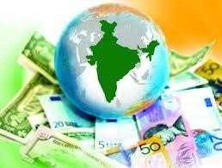India has one of the largest higher education systems in the world and there is still a lot of potential for further development. India has become the second largest market for e-learning after the US. The sector is expected to reach US$ 5.7 billion by 2020. The distance education market in India is expected to grow at a Compound Annual Growth Rate (CAGR) of around 11 % during 2016-2020. Moreover, the aim of the government to raise its current gross enrolment ratio to 30 per cent by 2020 will also boost the growth of the distance education in India. According to Department of Industrial Policy and Promotion (DIPP), total amount of Foreign Direct Investments (FDI) inflow into the education sector in India was US$ 1.42 billion from April 2000 to March 2017. In the Union Budget 2017-18, The Government of India has allocated around Rs 17,000 crore (US$ 2.55 billion) towards skilling, employment generation, and providing livelihood to millions of youth, in order to boost the Skill India Mission.

The Government of India and the World Bank have signed a US$ 201.50 million International Development Association (IDA) credit agreement for the Third Technical Education Quality Improvement Programme (TEQIP III), aimed at improving the efficiency, quality and equity of engineering education across several focus states. The Catalyst initiative by the Government of India and United States Agency for International Development (USAID) is expected to create awareness about digital payments across 60 million traders and merchants in the country.

Some major investments and developments in the recent past are as follows:

1. UAE-based Gamma Group, outlined plans of investing around Rs 3,000 crore (US$ 450 million) in the infrastructure, health and education sectors of Kerala, which is expected to generate around 2,000 indirect and direct jobs in the state.
2. Welingkar Institute of Management Development and Research has signed two memorandum of understanding (MoUs) with Israeli universities, namely Hafia University of Israel and IDC Herzliya, which includes pledging cooperation in the fields of study of technology, agriculture, archaeology, biology, etc.
3. International Finance Corporation (IFC) has invested US$ 15 million in education venture Byju’s for a minority stake, which is expected to help the test-preparation platform to expand domestically and internationally.